Farmer and Vendor Guide for EBT-Use at Farmers’ Markets
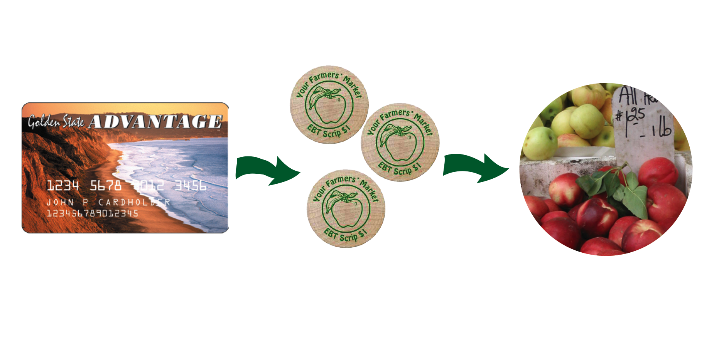
How the program works:
- The customer brings her CalFresh EBT card (the program formally known as food stamps) to the market information booth or locates the market staff person. She decides how much she wants to spend at the market and asks the market staff to sell her EBT scrip worth that amount.

- The market staff person swipes the card through the wireless POS terminal. The amount of the sale is debited from the customer’s card. The market staff person gives the customer EBT scrip for the full amount requested.

- The customer shops at the market for eligible foods, using scrip like cash. No change may be given.

- At the end of the market day, each farmer or vendor turns in all the scrip received to the market manager (usually while collecting stall fees), in exchange for cash, check or a receipt for the full value of scrip received.

- If the market manager gives the vendor a receipt for their EBT scrip, he or she will give the farmer or vendor a check for the amount of the receipt at the next market day (or my mail). If the farmer does not return to the market the following market day or if the farm owner requests, the manager will mail the check to the farm or vendor’s business address.

Program Rules:

- No US currency is to be given as change or exchanged for scrip in any manner. The sale must be for the exact amount of the scrip or the customer can make up the difference with cash.

- Accept only the market association’s scrip. No other market association scrip can be accepted at this market.

- All market vendors and farmers must accept scrip for eligible food products. Customers using EBT scrip must receive the same respect as other customers.

- All CalFresh eligible food items, food seeds and food plants can be purchased with EBT scrip.

- No hot food or non-food items such as flowers, clothing or crafts can be bought with EBT scrip.

Here is what an EBT Scrip Token might look like:

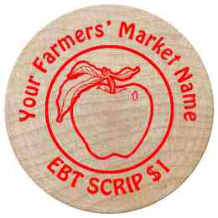

Eligible Food Items include foods for the household to eat, such as:
- Breads and cereals
- Fruits and vegetables
- Meats, fish and poultry, and dairy products
- Seeds and plants which produce food for the household to eat (food seeds and starts)

Households CANNOT use their EBT benefits to buy:
- Any non-food item
- Foods that will be eaten immediately
- Hot foods

Thank you for your participation!

